V.L Memorial Public School
475 Vijay Nagar
Chapter - 3 - Questions - Class6th - Science
CLASS 06 - SCIENCE (CURIOSITY)

 | Section A
1 | What is the role of the Food Safety and Standard Authority of India (FSSAI)?  a) Sustain the agricultural industry exclusively.  b) Regulate food quality and standards in India.  c) Ensure all food is organic.  d) Promote junk food consumption. | [1]
2 | Why should junk food be eaten less frequently?  a) It contains enough nutrients  b) It has too much sugar  c) It has too little fibre  d) It lacks several nutrients | [1]
3 | Why is reducing food miles important for the environment?  a) It makes food cheaper to produce  b) It increases the quality of food  c) It improves the taste of the food  d) It cuts down transport pollution | [1]
4 | Which of the following best describes an environmental benefit of reducing food miles?  a) Increases food portion sizes  b) Boosts packaging efficiency  c) Increases freshness indefinitely  d) Reduces greenhouse gases | [1]
5 | When a few drops of dilute iodine solution are added to a food, then a blue - black colour is produced. This food contains:  a) fat  b) carbohydrate  c) starch  d) protein | [1]
6 | Where in India is salt farming a traditional practice?  a) Gujarat  b) Rajasthan  c) Punjab  d) Kerala | [1]
7 | What does the term ’food miles’ refer to?  a) The number of miles one should walk after eating.  b) The lifespan of a packaged food item.  c) The amount of nutrients in food.  d) The distance food travels from its origin to your plate. | [1]
8 | Which of the following is the source of stored energy?  a) Vitamins  b) Carbohydrates  c) Fats  d) Proteins | [1]
9 | If a food item tests blue - black, what type of nutrient is present?  a) Lipid  b) Mineral  c) Vitamin  d) Carbohydrate | [1]
10 | What is a symptom of the disease goitre?  a) Rashes on skin  b) Swelling in limbs  c) Swelling at the front of the neck  d) Bleeding gums | [1]
11 | What is the consequence of leading an unhealthy lifestyle with poor dietary choices?  a) Improved mental health.  b) Instantaneous improvement in physical appearance.  c) Increased risk of several health problems.  d) Longer life expectancy. | [1]
12 | What does reducing food miles suggest about food consumption habits?  a) Consumption should focus on locally available resources  b) Processed foods are preferred  c) Packages foods are more environmentally friendly  d) Consumption should prioritize imported goods | [1]
13 | Primary source of energy is  a) vitamins  b) proteins  c) minerals  d) carbohydrates | [1]
14 | A student wants to increase dietary fibre through grains. Which choice would be most suitable?  a) Sweetened grains with added sugar  b) Millets such as ragi  c) Refined grains without fibre  d) Processed grains with fewer nutrients | [1]
15 | Night blindness is caused due to the deficiency of:  a) Vitamin B  b) Vitamin A  c) Vitamin D  d) Vitamin C | [1]
16 | What is one key advantage of minimizing food miles for consumers?  a) Food tastes better with longer travel distances  b) Packaging costs are lower  c) Food remains fresher and healthier  d) Fruits ripen faster | [1]
17 | A food company adds nutrients to a food during processing. What is this process called?  a) Food packaging  b) Food digestion  c) Food preservation  d) Food fortification | [1]
18 | Assertion (A): A proper balance of nutrients, including carbohydrates, proteins, fats, vitamins, and minerals,is necessary to maintain a healthy body.  Reason (R): Carbohydrates and fats are the only components in our diet that provide energy.  a) Both A and R are true and R is the correct explanation of A.  b) Both A and R are true but R is not the correct explanation of A.  c) A is true but R is false.  d) A is false but R is true. | [1]
19 | Assertion (A): Fats have less energy as compared to the same amount of carbohydrates.  Reason (R): Fats are obtained either from animals and from plants.  a) Both A and R are true and R is the correct explanation of A.  b) Both A and R are true but R is not the correct explanation of A.  c) A is true but R is false.  d) A is false but R is true. | [1]
20 | Assertion (A): Reducing food miles supports both local farmers and environmental sustainability.  Reason (R): Transporting food items long distances increases pollution and costs, negatively impacting the environment and economy.  a) Both A and R are true and R is the correct explanation of A.  b) Both A and R are true but R is not the correct explanation of A.  c) A is true but R is false.  d) A is false but R is true. | [1]
21 | Assertion (A): Millets have regained popularity due to their numerous health benefits.  Reason (R): They are not a significant source of dietary fibre.  a) Both A and R are true and R is the correct explanation of A.  b) Both A and R are true but R is not the correct explanation of A.  c) A is true but R is false.  d) A is false but R is true. | [1]
22 | Assertion (A): Consuming junk food can lead to obesity and health problems.  Reason (R): Junk foods contain essential nutrients, which improve our health when consumed frequently.  a) Both A and R are true and R is the correct explanation of A.  b) Both A and R are true but R is not the correct explanation of A.  c) A is true but R is false.  d) A is false but R is true. | [1]
23 | Assertion (A): Consuming locally grown food is healthier for our bodies.  Reason (R): Locally grown food often travels shorter distances, retaining its freshness better than imported items.  a) Both A and R are true and R is the correct explanation of A.  b) Both A and R are true but R is not the correct explanation of A.  c) A is true but R is false.  d) A is false but R is true. | [1]
24 | Assertion (A): Vitamins are required in very small quantities and protect our body against diseases.  Reason (R): They provide energy.  a) Both A and R are true and R is the correct explanation of A.  b) Both A and R are true but R is not the correct explanation of A.  c) A is true but R is false.  d) A is false but R is true. | [1]
25 | Name the component of food which is called body - building food. | [1]
26 | Which mineral is necessary for the formation of haemoglobin? | [1]
27 | Why might millets be preferred over other cereals in certain climatic conditions? | [1]
28 | How do millets contribute to the dietary needs of humans? | [1]
29 | What defines a balanced diet in terms of its nutritional content? | [1]
30 | What factors lead to the variation in food choices across different regions of India? | [1]
31 | Sugar is an example of carbohydrates. Sugar is tested with iodine solution but it does not change to blue - black colour. What can be a possible reason? | [1]
 | Section B
32 | Match the following: 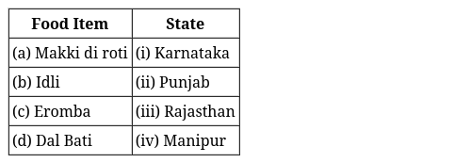 | [2]
33 | Match the following: 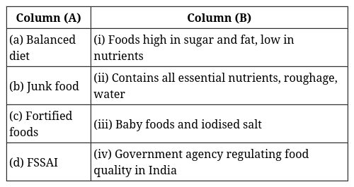 | [2]
34 | Evaluate the benefits of fortifying food products for public health. | [2]
35 | Describe how the deficiency of Vitamin C affects the human body and mention a related disease. | [2]
36 | Critically assess the limits of simple nutrient tests and their reliability. | [2]
37 | Analyze the effect of regional iodine deficiencies on public health and measures to rectify the situation. | [2]
38 | Identify and analyze the effects of cultural diversity on the dietary habits of people in India. | [2]
39 | Examine the relationship between balanced diets and deficiency diseases, using examples to support your argument. | [2]
40 | Evaluate the importance of public knowledge about simple nutrient tests. | [2]
 | Section C
41 | Discuss how detecting multiple nutrients in a single food item can impact dietary choices and health. | [3]
42 | Define the term ’food miles’ and explain its significance in the context of a healthy and sustainable lifestyle. | [3]
43 | Assess the significance of incorporating millets into the Indian diet over centuries. | [3]
44 | How can roughage and water contribute to a healthy digestive system? | [3]
45 | Discuss how cultural beliefs and traditions influence dietary habits in specific communities within India. | [3]
46 | Analyze the importance of nutrient labeling on packaged foods for consumer decision - making. | [3]
47 | A family replaces its sil - batta with an electrical grinder. Explain how this change reflects the development of modern culinary practices. | [3]
 | Section D
48 | Read the following text carefully and answer the questions that follow:  You may have heard of jowar, bajra, ragi, and sanwa. These are native crops of India. These crops can be easily grown in different climatic conditions. They are highly nutritious grains called millets. Millets are small grains that have been part of the Indian diet for centuries. They are now popular again because they are healthy. Millets are rich in vitamins, minerals like iron and calcium, and dietary fibres. Because of these health benefits, they are called nutri - cereals. They help in maintaining the balanced diet required for the normal functioning of our bodies.  Questions:  - Give two examples of millets native to India. ( 1 )  - Why are millets called nutri - cereals? ( 1 )  - State two health benefits of including millets in our diet. ( 2 )  - OR  - How do millets contribute to a balanced diet and help our body function properly? ( 2 ) | [4]
49 | Read the following text carefully and answer the questions that follow:  India is an agricultural country with diverse soil and climate types. Various crops are grown in its different regions depending on the soil types and climatic conditions. In various regions of India, the choice of food may vary according to the cultivation of food crops in that particular region, taste preferences, culture, and traditions.  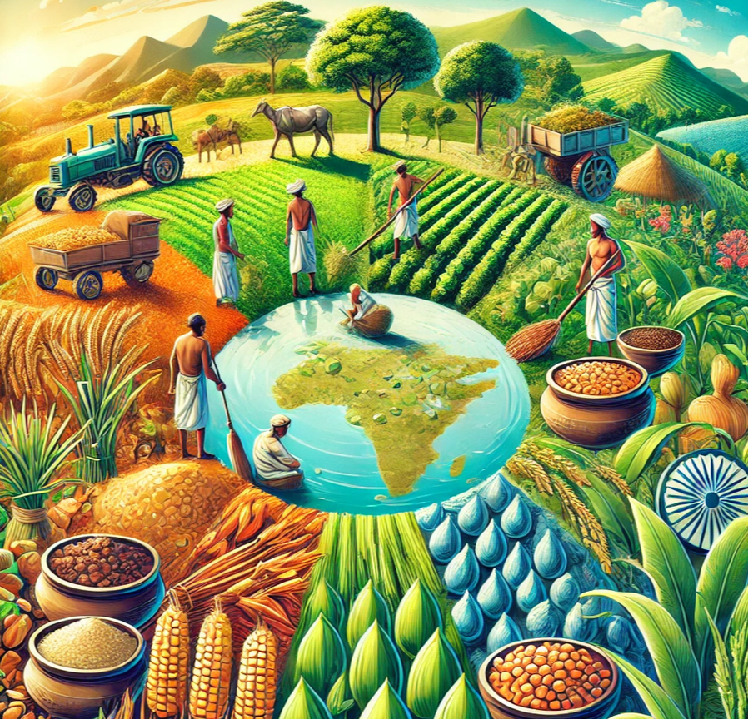  - Name one factor that influences the choice of crops grown in a particular region of India. (1)  - Why do food choices vary in different regions of India? (1)  - Explain how soil type and climate influence the cultivation of crops in different regions of India. (2)  - OR  - How do culture and traditions influence the food choices of people in different regions of India? (2) | [4]
50 | Read the following text carefully and answer the questions that follow:  Proteins are also an important part of our food. Milk products and pulses are good sources of protein. Sportspersons need proteins in larger quantities to build their muscles. People get proteins from plants as well as animals. Some excellent plant sources of protein are pulses, beans, peas and nuts. Animal sources of protein are milk, paneer, egg, fish and meat. Protein - rich foods help in growth and repair of our body. These are, therefore, called body - building foods.  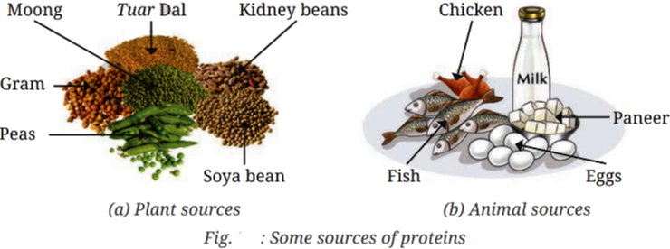  - Name two cereals that are rich sources of carbohydrates. (1)  - Name two seeds that are rich sources of fats. (1)  - Why are carbohydrates and fats called energy - giving foods? Provide two examples of carbohydrate - rich foods. (2)  - OR  - What is the role of fats in our diet? Give two examples of animal-based sources of fats. (2) | [4]
 | Section E
51 | Compare and contrast the traditional cooking practices with their modern counterparts, highlighting the advantages and disadvantages of each. Why have these transformations occurred? | [5]
52 | Why is a balanced diet necessary? What happens if we do not get enough nutrients? | [5]
53 | Given the role of carbohydrates and fats, suggest how one might balance the intake of these energy - giving foods for a healthy lifestyle. | [5]
54 | How would you test if a food item contains starch, protein, or fat? | [5]
55 | Propose a new experimental procedure to improve the detection of multiple nutrients in a simple home setting, considering current methods. | [5]
56 | Examine the role of nutrients in disease prevention and overall health improvement, supporting your answer with examples. | [5]
57 | How does detecting the presence of multiple nutrients in foods, such as peanuts, influence dietary choices and health recommendations? Discuss its implications. | [5]
 | Section F
58 | State whether the given statement is True or False:  - Ghee is a source of carbohydrates.  - Almonds are the main and the cheapest source of energy for body.  - Amla is the richest source of Vitamin A.  - A diet containing all the nutrients in their proper quantities is known as the balanced diet.  - A balanced diet lacks essential nutrients like carbohydrates and proteins.  - Calcium is essential for healthy development of bones and teeth.  - Different people have different choices of food.  - Grapes are better fruit than banana.  - Vitamins, minerals, iron, and calcium are some components not found in millets. | [9]
59 | Fill in the blanks:  - Deficiency of Vitamin B$​_{1}$ causes a disease known as________.  - The choice of food in various regions of India may vary according to the ________ of food crops in that particular region.  - Millets contribute significantly to a ________ diet.  - An energy - producing component of food is________.  - A ________ diet and avoidance of junk food are key to maintaining good health.  - Groundnuts are rich in________.  - Rickets is the disease caused by the deficiency of Vitamin________.  - Cooking practices, also known as ________ practices, have changed over time.  - Iodine solution changes the colour of ________ into blue - black. | [9]

